# The Team:

|  |  |  |
| --- | --- | --- |
| **Name** | **Roles** | **Contact** |
| Mujaheed Abubakar | Desktop developer  Mobile developer | 07440258680  [mujaheed.abubakar@students.plymouth.ac.uk](mailto:mujaheed.abubakar@students.plymouth.ac.uk) (preferred)  skype: mujaheed.abubakar |
| Craig Banyard | Lead database developer  Web developer  Mobile developer | 07584575250  [craig.banyard@students.plymouth.ac.uk](mailto:craig.banyard@students.plymouth.ac.uk)  skype: craig_b03 (preferred) |
| Joseph Kellaway | Lead web developer  Mobile developer  Database developer | 07472691769  [joseph.kellaway@students.plymouth.ac.uk](mailto:joseph.kellaway@students.plymouth.ac.uk) (preferred)  skype: j.kellaway88 |
| Zakaria Robinson | Project manager  HCI lead  Mobile developer | 077414459903  [zakaria.robinson@students.plymouth.ac.uk](mailto:zakaria.robinson@students.plymouth.ac.uk)  skype: Zaperon0 (preferred) |
| Daniel Scott | Lead software developer  API developer | 07594875693  [daniel.r.scott@students.plymouth.ac.uk](mailto:daniel.r.scott@students.plymouth.ac.uk)  skype: danzo111994 (preferred) |

# Tools:

|  |  |
| --- | --- |
| **Tool** | **Use** |
| Android Studio | Production of mobile applications for delivery staff. |
| Bitbucket | Online repository and source control. |
| Lucidchart | Production of ERDs and UML diagrams. |
| Microsoft Visual Studio | Production of API. |
| Notepad++ / Atom | Production of website for customers. |
| NetBeans IDE | Production of desktop application for chef and manager. |
| SQL Developer | Production of database. |
| Trello | Project/sprint management. |
| SQL Map | To test against SQL Injection and database attack |

# Initial Requirements Analysis & Design

## Product Backlog

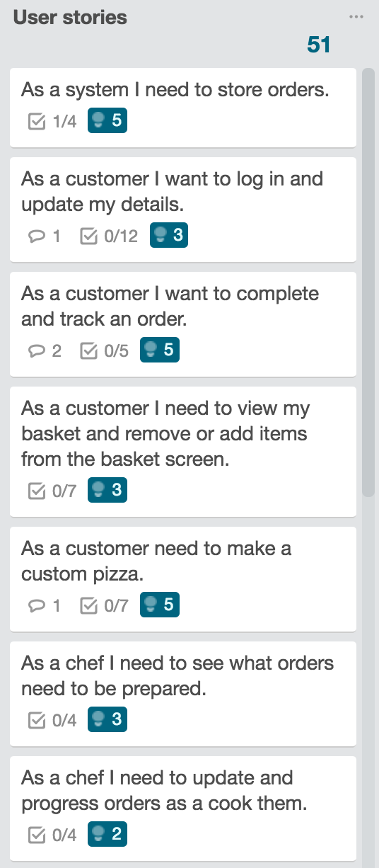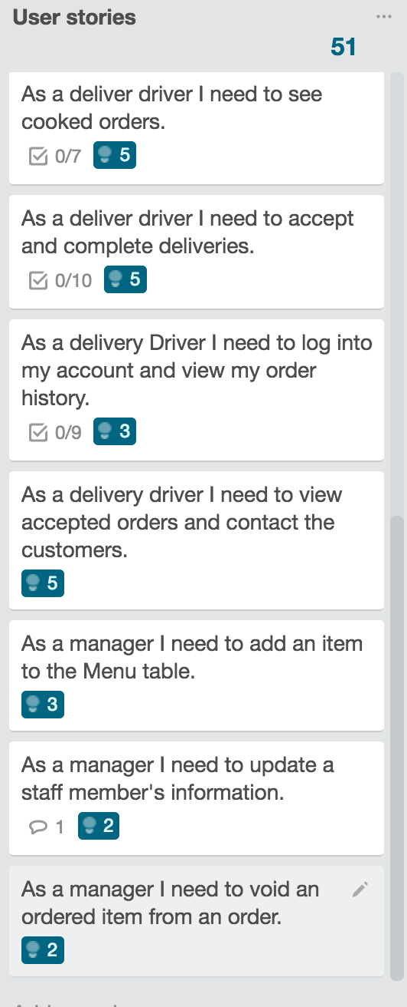

## Use Case Diagram

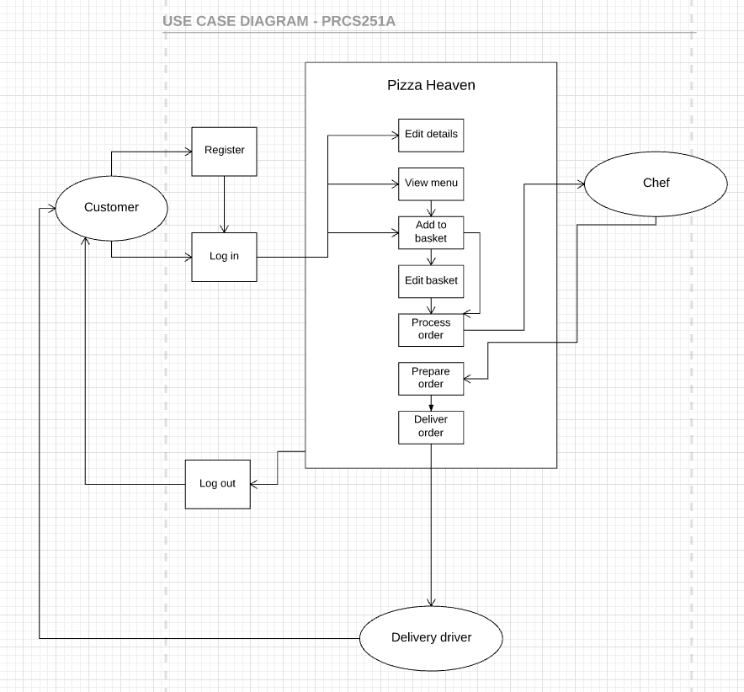

## Design Level Sequence Diagram

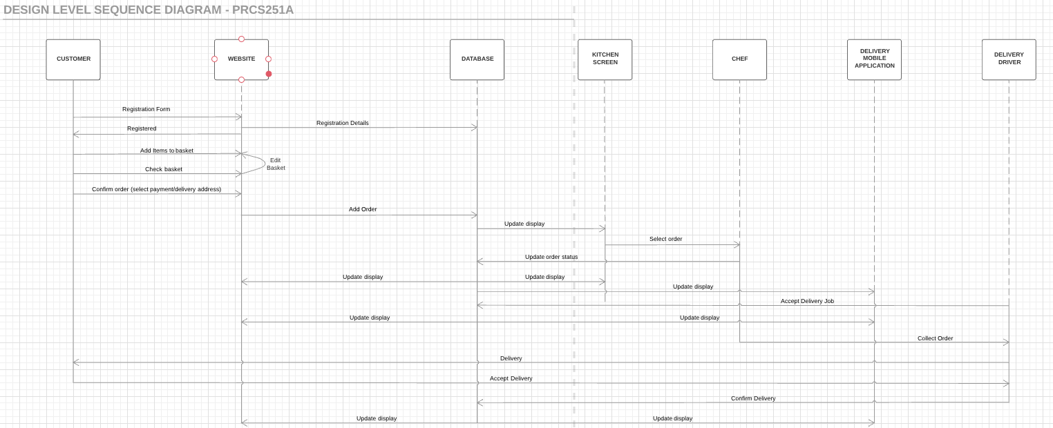

## State Machines Diagram../../../Desktop/Screen%20Shot%202017-02-23%20at%2011.42.36

## Rich Picture Diagram

## ../../../Desktop/Screen%20Shot%202017-02-23%20at%2011.59.33

## Class Diagram/ERD

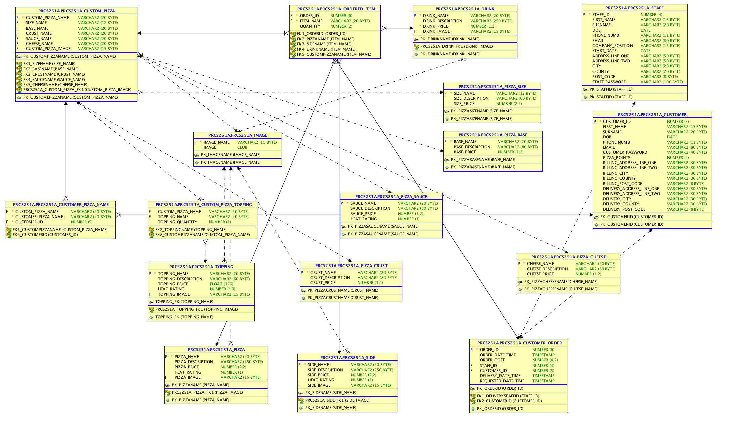

## Sprint Plan

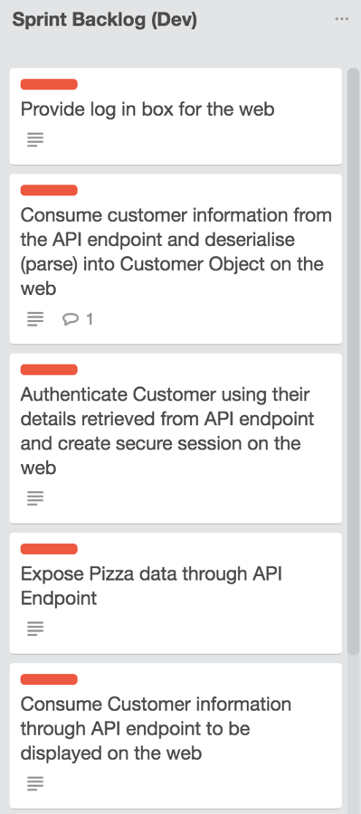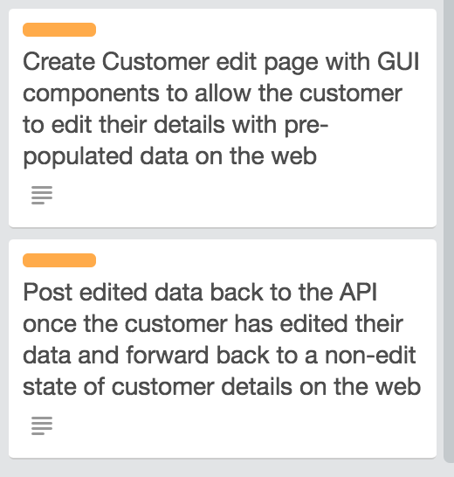

# Communications Plan:

Our communications plan varies from week to week based around our constantly-changing timetable. We have so far averaged over 10 hours per person per week, but this value will fluctuate based on our goals for the week, and the number of sessions we can schedule.

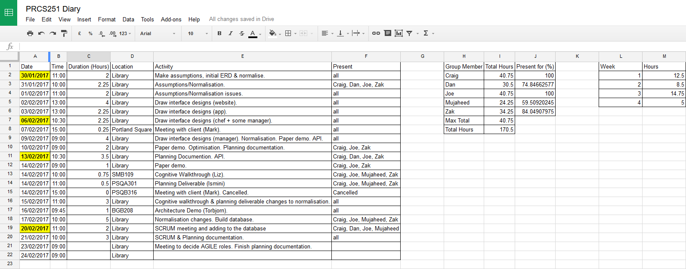

# Risk Analysis:

|  |  |  |  |
| --- | --- | --- | --- |
| **Risk** | **Probability** | **Impact** | **Course of Action** |
| Loss of small portions of project. | High | Low | Use repository to ensure up to date version accessible. |
| Loss of entire project. | Low | High | Keep numerous backups. |
| Equipment loss/damage. | Medium | Low | Use open access equipment. |
| Fall behind sprints/work takes longer than anticipated. | High | Medium | Invest more time into working on the project, reduce workload in future sprints and plan to remove parts of the system design reaching beyond the scope. |
| Team member stops contributing for any reason. | Low | Low | Accept risk until risk occurs and redistribute work accordingly. |
| Team lacks specific knowledge and/or skills to complete segment of assignment. | High | High | Accept that the assignment is part of a learning process and that we must develop and improve upon our current skill sets within the team. |
| User’s requirements change after they are gathered. | High (medium) | High (Low) | Keep logs of feedback from user with dates feedback was given. If the user changes their mind, then ask them to explain why they have changed their mind and re-adjust accordingly. Should reduce probability because the user may remember why they wanted the original requirements, will remove undesirable features to reduce impact on final product. |